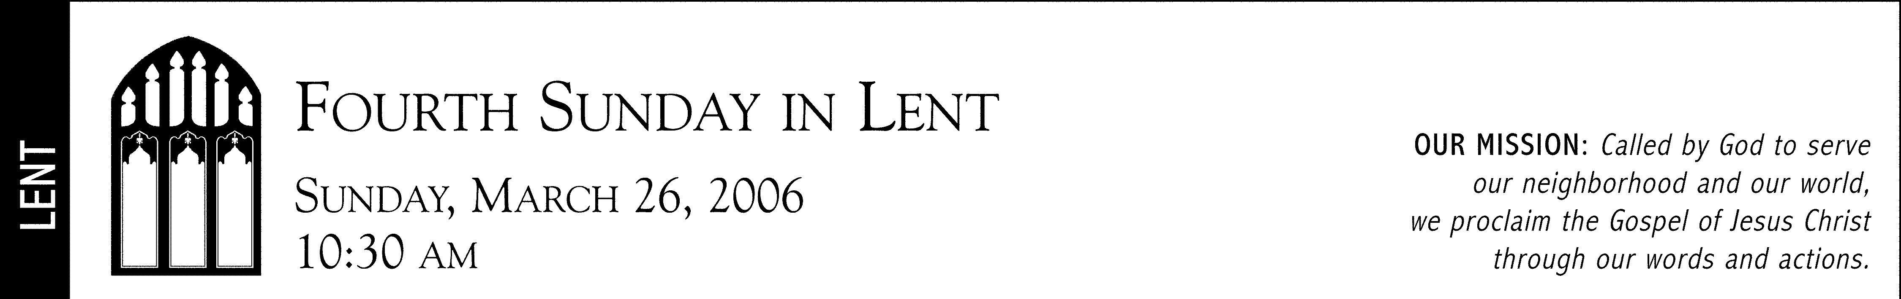
Compline
Wednesday, 17 February 2016
7:45 pm
7:00 pm

Saint Paul Lutheran and Roman Catholic Community of Faith  Denver, Colorado  www.stpauldenver.org

Welcome to Saint Paul Church, an open, affirming, and diverse community of faith representing two Christian traditions, that of the Evangelical Lutheran Church in America and that of the Roman Catholic Church. Each tradition maintains and honors its own heritage, and each worships according to its own liturgical practices. As one community of faith, the members of the respective traditions work together in social outreach and shared hospitality. Together we rejoice in the manner in which diversity has enriched, nurtured, and challenged the life and ministry we share in Christ, and we regret actions and attitudes throughout the Church that may have inhibited or prevented access to Word and Sacrament because of age, race, socio-economic or marital status, physical or mental capacities, gender identity, or sexual orientation. We are a Reconciling in Christ community.

P=Presiding Minister C=Congregation

Trust _____________________________________________________________________________________________________________________

We sum up this day with a bedtime prayer to examine our conscience and offer our actions to God.

Opening
P: Give us the grace to rely on you
C: may we always trust in your goodness

Prayer
P: Let us pray.
Enduring presence, goal and guide, you go before and await our coming. On our thirst compels us beyond complaint to conversation, beyond complaint to conversation, beyond rejection to relation. Pour your love into our hearts that, refreshed and renewed, we may invite others to the living water given to us in Jesus Christ our Lord.
C: Amen

Praise
P: O God of gentle strength, your love embraces me.
Within the sureness of your care my heart rests willingly.
C: Your waters of rebirth have claimed us as your own.
As members of one body, we shall never be alone.
P: And when life’s challenges eclipse our minds with doubt,
Let holy wisdom spark a flame to drive the darkness out.
C: Where will the journey lead? The path may be obscure.
But promised hope of things unseen will keep our footing sure.

Scripture: Isaiah 30: 15a, 18
P: Thus says the Lord God, the Holy one of Israel; In returning and rest you shall be saved; in quietness and confidence shall be your strength. Therefore the Lord waits to be gracious to you; therefore he will rise up to show mercy to you. For the Lord is a God of justice. Blessed are all those who wait for the Lord.

Meditation: Li Po, 8th Century poet
P: The birds have vanished into the sky,
And now the last cloud drains away.

We sit together, the mountain and me,
Until only the mountain remains.

What do we need to trust this fully in God’s grace?

Prayer
P: Let us pray.
Patient and Compassionate God,
We so want to trust in your love.
C: Hear our longing.
P: We hope for healing in our lives and the lives of others:

Here the people may add particular intercessions or thanksgivings.

P: Hear our prayers
C: Heed our holy desires.
P: We confess our impatience and anxiety.
C: We seek your grace.

Lord’s Prayer
C: Our Father in heaven, hallowed be your name, your kingdom come, your will be done, on earth as in heaven. Give us today our daily bread. Forgive us our sins as we forgive those who sin against us. Save us from the time of trial, and deliver us from evil. For the kingdom, the power, and the glory are yours, now and forever. Amen.

Prayer
P: Let us pray.
O Lord and Ruler of our life: Deliver us from the spirit of sloth, idle talk, faint-heartedness, and lust for power; and grant unto us, your servants, a spirit of integrity, humility, patience and love. Sovereign God, grant us the ability to see our own faults and not to judge another’s; for you are blessed to the ages of ages.
C: Amen

Closing
P: Give us the grace to rely on you:
C: may we always trust in your goodness.

The Rev. Dr. Kevin R. Maly, Pastor (ELCA)
The Rev. Dr. Donald Sutton, Pastor (Roman Catholic)
Mark Alan Filbert, Cantor  Kirsten Boyd, Parish Administrator  Mohamed Jamoum, Sexton
___________________________________________________________________________________________________________________________________________________________________________________________________________________________________________________

SAINT PAUL LUTHERAN AND ROMAN CATHOLIC COMMUNITY OF FAITH
1600 Grant Street  Denver, Colorado 80203-1602  Phone: 303.839.1432  Website: www.StPaulDenver.org

